LOGBOOK –8

1. LSTM architecture using model.summary():

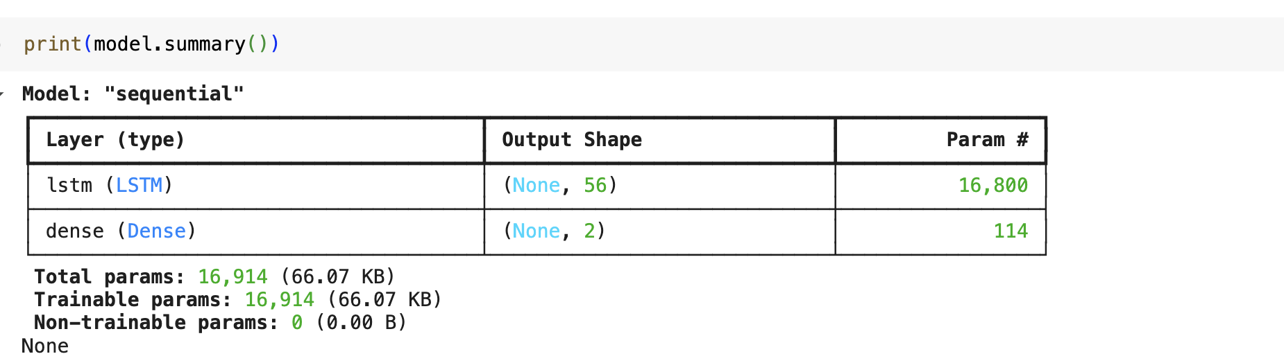

1. Code and training result using model.fit():

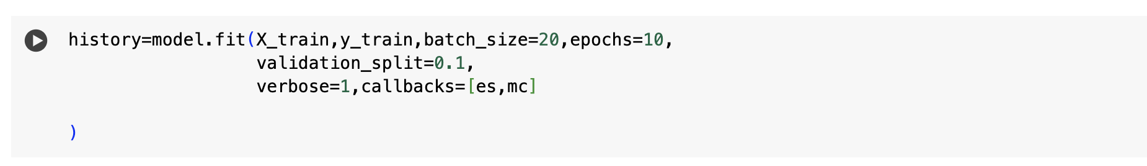

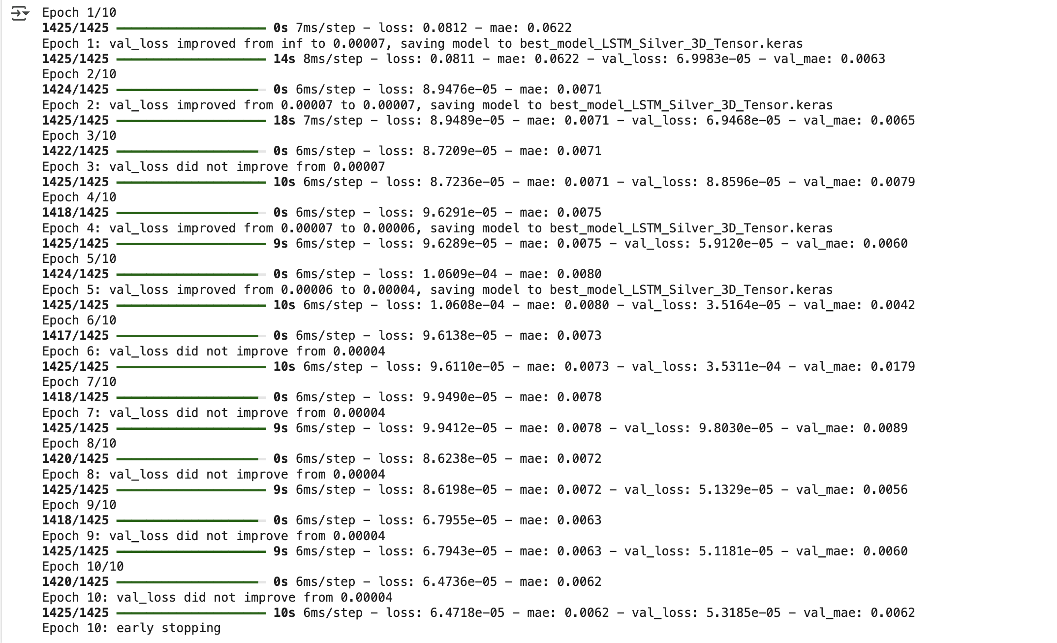

1. The resulting test MSE & MAE:

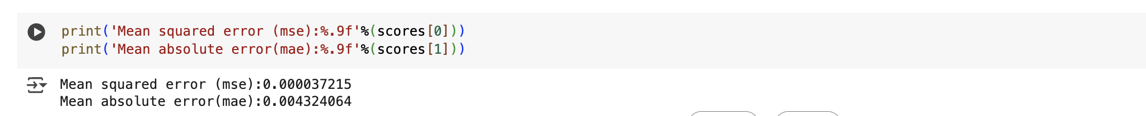

1. MAE Detailed Graph

